Members are summoned to attend a Parish Council Meeting on Monday 25 February 2019 at 7.30 pm in the Village Hall to transact the following business:

AGENDA

- To receive any apologies.

- Public Open Session - to consider any matters raised by members of the public.
The Chairperson will also invite members of the public to contribute during the meeting on appropriate matters.

- Members’ declaration of interests.

- To approve the minutes of the meeting held on 21 January 2019

- To hear reports from:
- PCSO
- District Councillor
- County Councillor

- Council Matters, including implementation of the Community Plan
- To receive reports from members on their areas of responsibilities, specifically in relation to the Community Plan including:
- HD2 provision of a minimum of four affordable homes in the Parish (TG/MH)
- To hear an update on the work of Charlton Horethorne Community Land Trust. (Mark Hughes)
- HD3 provision of small number of downsizing/retirement homes in the village (TG/MH)
- HD 4 & 5 provision of a small number of workshops and office units in the village (MH/GM)
- ES1, 2 & 3 – investigation of the demand for new facilities for young children, teenagers and sporting activities (AR)
- TRS 1 to 7 – Traffic and road safety issues (TD)
- To hear an update from the Clerk on a local Speed Indicator Device scheme and agree any action to be taken.
- To hear an update on arrangements for the Annual Parish Meeting, taking place on Saturday 30 March.
- To note that the Parish Council’s historical documents have been deposited with South West Heritage Trust.
- To consider requests for a defibrillator in the Parish.

- Financial Matters
- To note the quarter 3 budget monitoring report.
- To approve the cash book and bank reconciliation for the period to 24 January 2019.
- To approve payments of:
Zöe Godden | Salary & expenses February 2019 | £149.36
HMRC | Income tax re Z Godden February 2019 | £32.00
Viking | Printer ink & staples | £29.37

- To consider a request for a grant from Yeovil Shopmobility.
- Any other financial matters.

- Planning
- To report any relevant planning decisions made by SSDC: 18/02865/FUL – Slait Cottage, Sigwells, DT9 4LN - The erection of a two storey rear extension and a two storey annexe extension. – Granted with conditions

- To consider the following planning applications and make recommendations to SSDC:
i | 18/04045/FUL | Demolition of the existing dwelling (Use C3) and part of the adjacent barn. Erection of a replacement dwelling (Use Class C3) with associated works. | Gunville Farm Bungalow, Harvest Lane, Charlton Horethorne. DT9 4PH
ii | 18/04047/FUL | Demolition of the existing barns and the erection of two dwellings (Use Class C3) along with associated works. | Land Os 9090 Part, Charlton Horethorne. DT9 4PH
Iii | 19/00232/S73A | Section 73 application to vary condition 15 of approval 17/04715/FUL relating to approved plans condition for the substitution of drawings. | The Manor, Horse Lane, Charlton Horethorne. DT9 4NL
iv | 19/00293/S19 | Section 19 application to vary condition 14 of approval 17/04716/LBC relating to approved plans condition for the substitution of drawings. | The Manor, Horse Lane, Charlton Horethorne. DT9 4NL

- To hear an explanation from SSDC regarding issues with their website that prevent the download of planning decision notices.

- Items of Report / Future Business

- Public Open Session - to consider any matters raised by members of the public.

- Date of Next Meeting: 30 March 2019 – Annual Parish Meeting; 08 April 2019 – Parish Council meeting

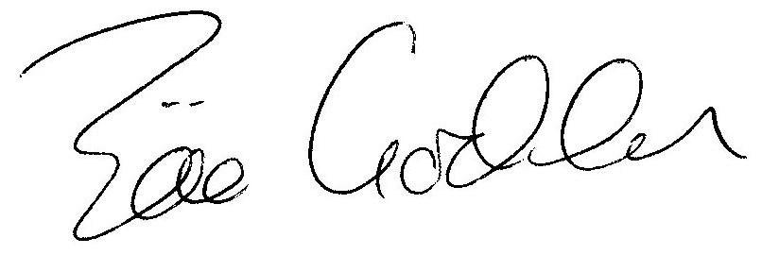

Zöe Godden
Parish Clerk

