Parish Council Meeting on Monday 21 January 2019 at 7.30 pm in the Village Hall
to transact the following business:

- To receive any apologies.

- Public Open Session - to consider any matters raised by members of the public.
The Chairperson will also invite members of the public to contribute during the meeting on appropriate matters.

- Members’ declaration of interests.

- To approve the minutes of the meeting held on 26 November 2018

- To hear reports from:
- PCSO
- District Councillor
- County Councillor

- Council Matters, including implementation of the Community Plan
- To receive reports from members on their areas of responsibilities, specifically in relation to the Community Plan including:
- HD2 provision of a minimum of four affordable homes in the Parish (TG/MH)
- To hear an update on the work of Charlton Horethorne Community Land Trust. (Mark Hughes)
- HD3 provision of small number of downsizing/retirement homes in the village (TG/MH)
- HD 4 & 5 provision of a small number of workshops and office units in the village (MH/GM)
- ES1, 2 & 3 – investigation of the demand for new facilities for young children, teenagers and sporting activities (AR)
- TRS 1 to 7 – Traffic and road safety issues (TD)
- To consider nominating any suitable sites where the Dorset and Somerset Air Ambulance might be able to land in the Parish. (AR)
- To note that Christmas tree recycling was again provided by SSDC free of charge in the Parish.
- To consider allowing the Clerk to attend a training session organised by SALC called “The Essential Clerk”, the total cost of which is £85 but will be split equally three ways with her other two parishes, meaning the cost to Charlton Horethorne Parish Council would be £28.34.
- To consider allowing the Clerk to attend a free Election Information Session held by SSDC and to pay £8.55 as a third of the mileage costs.
- To note that Parish Council elections will take place in May 2019 and to consider how to promote these and encourage residents to put their names forward for nomination.
- To agree arrangements for the Annual Parish Meeting, taking place on Saturday 30 March.

- Correspondence
- To note receipt of an invitation from SSDC to comment on the draft updated Rural Housing Plan 2019-21 and agree any member(s) to comment

- Financial Matters
- To approve the cash book and bank reconciliation for the period to 24 December 2018.
- To approve two payments made on 31 December 2018, outside of a public meeting, as follows:
Zöe Godden | Salary December 2018 | £128.00
HMRC | Income tax re Z Godden December 2018 | £32.00
- To approve payments of:
Zöe Godden | Salary Jan 2019 & expenses Dec 2018 & Jan 2019 | £180.79
HMRC | Income tax re Z Godden Jan 2019 | £32.00
Henstridge Parish Council | 10% SLCC membership & 1/3 share of SLCC Regional Training Seminar costs | £45.03

- To agree the budget for 2019-20, including the consideration of grant applications from the Stowell PCC, Charlton Horethorne PCC, Charlton Horethorne Village Hall and the Millennium Green Trust and quotes for Village Green maintenance for 2019-20.
- To agree the precept request for 2019-20.
- Any other financial matters.

- Planning
- To hear an update on the appeal relating to planning application 17/03405/FUL - Erection of two dwellings, provision of access, diversion of public right of way, landscaping and ancillary works, Land OS 0084 At Gunville Farm, Violet Lane, Charlton Horethorne.
- To note receipt of a response to the Clerk’s letter to SSDC regarding the refusal of planning application 18/01446/COU (Manor Dairy Farm) and to agree any action to be taken.
- To report any relevant planning decisions made by SSDC: 18/02600/FUL - Charlton Hill Farm, Sigwells. DT9 4LZ - The erection of a single storey extension to form ancillary annexe with a carport and glazed link, extension to existing porch to form boot room and the realignment of boundary fences. – Granted with conditions
- To note that the Parish Council decided it was unnecessary to convene a special meeting to consider a planning application and made comments as follows: 18/02865/FUL - Slait Cottage, Sigwells. DT9 4LN - The erection of a two storey rear extension and a two storey annexe extension. – RESPONSE TO SSDC: Charlton Horethorne Parish Council has not met to discuss the above application because of the short timescale given for our response. However, the Chair and lead member for planning have visited the applicant and near neighbours. There have been no objections received. All Councillors have discussed the application with each other verbally or by email and have reached the following decision: The Parish Council unanimously supports the application.

- Items of Report / Future Business

- Public Open Session - to consider any matters raised by members of the public.

- Date of Next Meeting: 25 February 2019

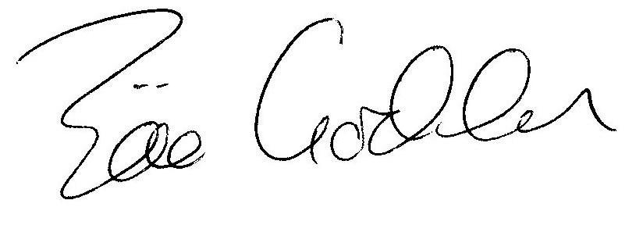

Zöe Godden
Parish Clerk

