Parish Council Meeting on Monday 26 November 2018 at 7.30 pm in the Village Hall
to transact the following business:

- To receive any apologies.

- Public Open Session - to consider any matters raised by members of the public.
The Chairperson will also invite members of the public to contribute during the meeting on appropriate matters.

- Members’ declaration of interests.

- To approve the minutes of the meeting held on 08 October 2018

- To hear reports from:
- PCSO
- District Councillor
- County Councillor

- Council Matters, including implementation of the Community Plan
- To receive reports from members on their areas of responsibilities, specifically in relation to the Community Plan including:
- HD2 provision of a minimum of four affordable homes in the Parish (TG/MH)
- To hear an update on the work of Charlton Horethorne Community Land Trust. (Mark Hughes)
- HD3 provision of small number of downsizing/retirement homes in the village (TG/MH)
- HD 4 & 5 provision of a small number of workshops and office units in the village (MH/GM)
- ES1, 2 & 3 – investigation of the demand for new facilities for young children, teenagers and sporting activities (AR)
- To note that the Parish Council has achieved Quality status from its submission to the Local Council Award Scheme.
- To resolve that the Parish Council confirms the eligibility criteria for the General Power of Competence as set out in the Localism Act 2011 and that Council adopts the power, namely that it has a qualified Clerk and that at least two thirds of vacancies were filled at the last ordinary election.

- Financial Matters
- To approve the cash book and bank reconciliation for the period to 24 October 2018.
- To approve two payments made on 2 November 2018, outside of a public meeting, as follows:
Zöe Godden | Salary October 2018 | £128.00
HMRC | Income tax re Z Godden October 2018 | £32.00

- To approve payments of:
Zöe Godden | Salary Nov & expenses Oct & Nov 2018 | £158.39
HMRC | Income tax re Z Godden Nov 2018 | £32.00
Charlton Horethorne Village Hall | Hall hire Oct & Nov 2018 | £32.00
Milborne Port Computers | Website maintenance, domain & email registration and hosting | £132.00

- To consider allowing the Clerk’s December salary (£128.00) and the associated HMRC liability (£32.00) to be paid before the next meeting on 14 January 2019.

- To note receipt of grant applications from the Stowell PCC and Charlton Horethorne Village Hall, both of which will be considered under the participatory budgeting exercise. A final decision on the level of grant to be awarded will be made at the Parish Council meeting on 14 January 2019.
- To open the meeting to the public for a participatory budgeting exercise.
- Any other financial matters.

- Correspondence
  - To note receipt of an email from SCC informing members of reductions to the precautionary gritting network and removal of the provision of roadside grit; to consider any action to be taken.
  - To note receipt of an update for Town & Parish Councils from South Somerset Community Accessible Transport.
  - To note an email from SCC regarding the cessation of the Speed Indicator Device scheme and to agree any action to be taken.
  - To note an email from Charlton Horethorne Village Hall regarding upcoming renovation work.

- Planning
- To note receipt of an advice of appeal relating to planning application 17/03405/FUL - Erection of two dwellings, provision of access, diversion of public right of way, landscaping and ancillary works, Land OS 0084 At Gunville Farm, Violet Lane, Charlton Horethorne; to consider any comments to make to the Planning Inspectorate.
- To report any relevant planning decisions made by SSDC:
  - 18/01446/COU - Dairy Farm, Charn Hill, Charlton Horethorne, DT9 4NZ - Change of use of part of building from agricultural to B2 (general industrial) – REFUSED
  - 18/02616/DPO - Stowell Farm, Stowell Road, Stowell, DT9 4PE - Application to discharge a S106 agreement dated 15th June 2007 between South Somerset District Council and Roy Walter Kingman and Elizabeth Jayne Kingman and Ronald Walter Kingman and Edna Joyce Kingman relating to non-fragmentation of land and the restriction on occupation of dwelling. PLANNING OBLIGATION DISCHARGED

- Items of Report / Future Business

- Public Open Session - to consider any matters raised by members of the public.

- Date of Next Meeting: 21 January 2019

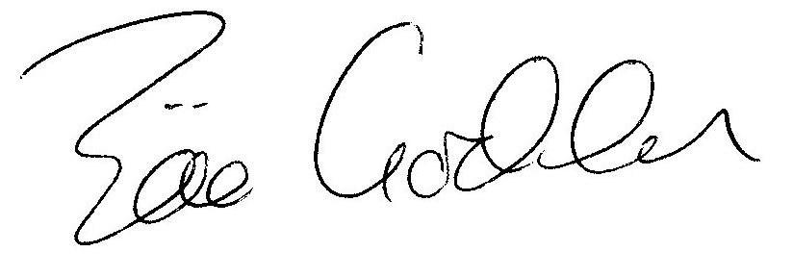

Zöe Godden
Parish Clerk

