CHARLTON HORETHORNE PARISH COUNCIL
www.charltonhorethornepc.org.uk

Parish Council Meeting on Monday 08 October 2018 at 7.30 pm in the Village Hall
to transact the following business:

- To receive any apologies.

- Public Open Session - to consider any matters raised by members of the public.
The Chairperson will also invite members of the public to contribute during the meeting on appropriate matters.

- Members’ declaration of interests.

- To approve the minutes of the meeting held on 20 August 2018

- To consider matters arising from the minutes: None at time of publishing the agenda.

- To hear reports from:
- PCSO
- District Councillor
- County Councillor

- Council Matters, including implementation of the Community Plan
- Opportunity for members to report on their areas of responsibility, specifically in relation to the Community Plan including:
- HD2 provision of a minimum of four affordable homes in the Parish (TG/MH)
- To hear an update on the work of Charlton Horethorne Community Land Trust. (Mark Hughes)
- HD3 provision of small number of downsizing/ retirement homes in the village (TG/MH)
- HD 4 & 5 provision of a small number of workshops and office units in the village (MH/GM)
- ES1, 2 & 3 – investigation of the demand for new facilities for young children, teenagers and sporting activities (AR)
- To note issues reported by Jane Jeanes, Parish Paths Liaison Officer and consider any action to be taken.
- To consider allowing the Clerk to attend the Society of Local Council Clerks South West Regional Seminar on 28th November at a total cost of up to £46.18.

- Financial Matters
- To approve the cash book and bank reconciliations for the periods to 24 August and 24 September 2018.
- To note the budget monitoring sheet for quarter 2.
- To approve two payments made on 3 September 2018, outside of a public meeting, as follows:
Zöe Godden | Salary August 2018 | £128.00
HMRC | Income tax re Z Godden Aug 2018 | £32.00

- To approve the following accounts for payment and two signatories for cheques:-
Zöe Godden | Salary & expenses September 2018 | £160.80
Zöe Godden | LCAS and Transparency Code overtime | £234.72
HMRC | Income tax re Z Godden September 2018 | £90.60
WALC | LCAS accreditation fee | £96.00

- To consider authorising payment of the Clerk’s October salary (£128.00) and associated HMRC payment (£32.00) before the November meeting.
- To note that £400 has been transferred from the current account to the deposit account as per the 2018/19 budget.
- To note budget consultation process for 2019/20
- Any other financial matters.

- Correspondence:
- To note an invitation to members and the wider community from Henstridge Parish Council and Avon & Somerset Police to attend a community event, offering tips to stay safe online, prevent fraud and keep safe at home on Wednesday 31 October at 7pm.
- To note receipt of information from South Somerset Citizens Advice regarding funding arrangements with Somerset County Council and consider any action to be taken.
- To note receipt of an invitation from Spark for members to attend an event called “Improving Health & Wellbeing in Your Community” on 16 October in Somerton and agree if any members will attend.
- To consider commenting on SSDC’s draft statement of principles relating to the Gambling Act 2005.

- Planning
- To consider the following planning applications and make recommendations to SSDC:
i | 18/02600/FUL | The erection of a single storey extension to form ancillary annexe with a carport and glazed link, extension to existing porch to form boot room and the realignment of boundary fences. | Mr & Mrs P Taylor, Charlton Hill Farm, Sigwells. DT9 4LZ
ii | 18/02920/AGN | Notification of intent to erect an agricultural storage building | Land OS 3575, Stowell Hill. Horsington

- To report any relevant planning decisions made by SSDC: none at time of publishing the agenda
- To note that the Parish Council decided it was unnecessary to convene a special meeting to consider a planning applications and made comments as follows: 18/02616/DPO - Stowell Farm, Stowell Road, Stowell. DT9 4PE- Application to discharge a S106 agreement dated 15th June 2007 between South Somerset District Council and Roy Walter Kingman and Elizabeth Jayne Kingman and Ronald Walter Kingman and Edna Joyce Kingman relating to non-fragmentation of land and the restriction on occupation of dwelling.– RESPONSE TO SSDC: Charlton Horethorne Parish Council has not met to discuss the above application because of the short timescale given for our response. However, the Chair and lead member for planning have visited the applicant and near neighbour. There have been no objections received. All Councillors have discussed the application with each other verbally or by email and have reached the following decision: The Parish Council has no objection to the planning application provided statutory requirements are met.
- To note that contacting planning officers at SSDC has become increasingly difficult and to agree any action to be taken. (TG)
- To note receipt of a briefing and guidance regarding the Community Infrastructure Levy from SSDC and agree any action to be taken.

- Items of Report / Future Business

- Public Open Session - to consider any matters raised by members of the public.

- Date of Next Meeting: 26 November 2018

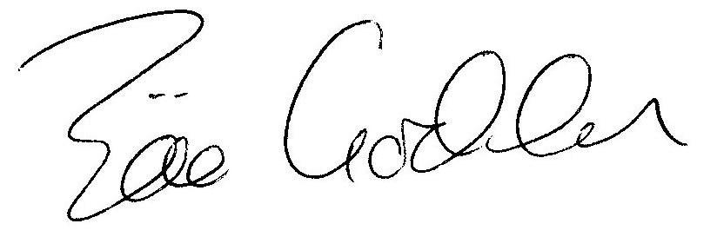

Zöe Godden
Parish Clerk

