CHARLTON HORETHORNE PARISH COUNCIL
www.charltonhorethornepc.org.uk

Parish Council Meeting on Monday 20 August 2018 at 7.30 pm in the Village Hall
to transact the following business:

- To receive any apologies.

- Public Open Session - to consider any matters raised by members of the public.
The Chairperson will also invite members of the public to contribute during the meeting on appropriate matters.

- Members’ declaration of interests.

- To approve the minutes of the meeting held on 9 July 2018

- To hear reports from:
- PCSO
- District Councillor
- County Councillor

- To consider matters arising from the minutes: None at time of publishing the agenda.

- Council Matters, including implementation of the Community Plan
- To receive reports from members on their areas of responsibilities, specifically in relation to the Community Plan including:
- HD2 provision of a minimum of four affordable homes in the Parish (TG/MH)
- To hear an update on the work of Charlton Horethorne Community Land Trust. (Mark Hughes)
- HD3 provision of small number of downsizing/retirement homes in the village (TG/MH)
- HD4 & 5 provision of a small number of workshops and office units in the village (MH/GM)
- ES1, 2 & 3 – investigation of the demand for new facilities for young children, teenagers and sporting activities (AR)

- Financial Matters
- To approve the cash book and bank reconciliation for the period to 24 July 2018.
- To approve payments of:
Zöe Godden | Salary & expenses July 2018 | £158.80
HMRC | Income tax re Z Godden July 2018 | £ 32.00
Charlton Horethorne Village Hall | Hall hire April, May, June & July 2018 | £ 72.00
Viking | Printer cartridges | £ 37.76
Henstridge Parish Council | 1/3 share of Clerk’s Principal membership of SLCC | £ 8.33

- Any other financial matters.

- Correspondence: SALC – Invitation to respond to an LGA green paper on the topic of adult social care and wellbeing; to agree if a member(s) would respond.

- Planning
- To consider the following planning applications and make recommendations to SSDC: none at time of publishing the agenda
- To report any relevant planning decisions made by SSDC: 18/01079/FUL – Land adjoining Wynfield, Cowpath Lane, Charlton Horethorne – Erect dwelling – Application withdrawn.
- To note that the Parish Council decided it was unnecessary to convene a special meeting to consider a planning applications and made comments as follows: 18/01869/FUL - Goose Cottage, Maperton Road, Charlton Horethorne. DT9 4NT - The erection of a two storey building to form a replacement garage/store and a single storey building to form an office/bedroom. – RESPONSE: The Parish Council has not been able to hold a meeting to discuss this application due to the short response timescale. We have visited the applicant and six adjacent properties. There have been no objections to the application. PC members have consulted each other via email and have no objections to the application. We do have sympathy with the view of the Conservation Officer about the dormer window in the proposed garage and would prefer it to be replaced with a velux or similar. We are also concerned that adequate measures will be in place to deal effectively with both surface and foul water from the proposed buildings. The present house is not on mains drainage.

- Items of Report / Future Business

- Public Open Session - to consider any matters raised by members of the public.

- Date of Next Meeting: 08 October 2018

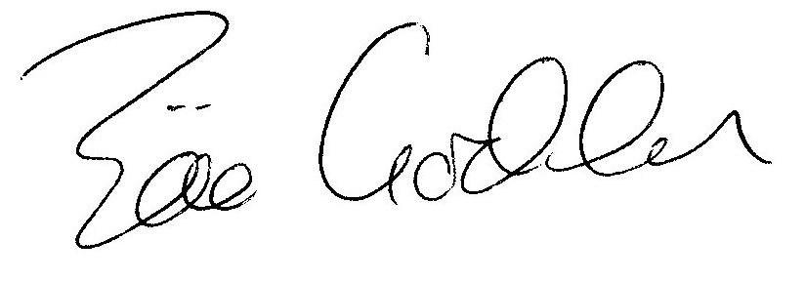

Zöe Godden
Parish Clerk

