CHARLTON HORETHORNE PARISH COUNCIL
www.charltonhorethornepc.org.uk

Parish Council Meeting on Monday 9 July 2018 at 7.30 pm in the Village Hall
to transact the following business:

- To receive any apologies.

- Public Open Session - to consider any matters raised by members of the public.
The Chairperson will also invite members of the public to contribute during the meeting on appropriate matters.

- Members’ declaration of interests.

- To approve the minutes of the meetings held on 21 May 2018

- To hear reports from:
- PCSO
- District Councillor
- County Councillor

- To consider matters arising from the minutes.
- To review the bank mandate and agree any changes.
- To consider allowing members to sign a form from Nat West Bank to apply for Online Banking services.

- Council Matters, including implementation of the Community Plan
- To receive reports from members on their areas of responsibilities, specifically in relation to the Community Plan including:
- HD3 provision of small number of downsizing/ retirement homes in the village (TG/MH)
- HD 4 & 5 provision of a small number of workshops and office units in the village (MH/GM)
- ES1, 2 & 3 – investigation of the demand for new facilities for young children, teenagers and sporting activities (AR)
- To note that the Council’s application to the Local Council Award Scheme has been submitted.
- To discuss bus service provision in the Parish and agree any action to be taken. (MH)

- Financial Matters
- To approve the cash book and bank reconciliation for the period to 22 June 2018.
- To approve the Q1 budget monitoring sheet.
- To approve payments of:
Zöe Godden | Salary and expenses June 2018 | £161.94
HMRC | Income tax re Z Godden June 2018 | £ 32.00
SALC | Responding to Planning Applications training (Tim Daniel) | £ 30.00

- To consider contributing to the cost of the Clerk’s Principle membership of the Society of Local Council Clerks of £16.66.
- To consider a grant application in relation to WW1 commemorations.
- To note that Ann Reeder, Tim Daniel and the Clerk have attended a SALC training course called Responding to Planning Applications. To agree to cover the cost of Tim Daniel’s place and 1/3 of the Clerk’s place on the course, amounting to £40.00.
- For the Chairperson to receive Parish Council related passwords in a sealed and dated envelope to be opened only if required, in line with financial regulation 6.11.
- To hear an update on the application for online banking services and to consider signing a letter to allow the Clerk to speak to the bank on behalf of the Parish Council
- Any other financial matters.

- Correspondence: none at time of publishing the agenda

- Planning
- To consider the following planning application and make recommendations to SSDC: none at time of publishing the agenda
- To report any relevant planning decisions made by SSDC:
18/01203/COU - 1 Blackford Way, North Road, Charlton Horethorne. DT9 4NS - Change of use of land from agricultural to residential – Granted with conditions
- To note that the Parish Council decided it was unnecessary to convene a special meeting to consider a planning applications and made comments as follows: 18/01446/COU - Manor Dairy Farm, Charn Hill, Charlton Horethorne. DT9 4NZ - Change of use of part of building from agricultural to B2 (general industrial) – RESPONSE: We have not been able to meet as a Parish Council within the time scale for making observations to South Somerset District Council. However, we have consulted parishioners and have received several representations. We have also visited the site and met the applicant. One of the policies in our Community Plan (Policy HD4) says: “Two additional small workshop units (for non-intrusive light industrial/service use) should be provided in the parish by the end of 2022 to promote local employment”. We understand that the present site for Marshalls Metal Fabrications at the Manor will no longer be available in the future and that its relocation to the application site would prevent the loss of that light industrial use in the village. We believe that it is important that the village retains small businesses such as Marshalls and continues to be a working village. We recognise and understand the concerns expressed by parishioners about noise and traffic that could result from this change of use. However, we believe these issues can be satisfactorily resolved and would expect that normal conditions regarding noise control, hours of operation and traffic are applied to any permission that is granted. We understand that noise abatement measures are already in place in the new building. Traffic movements and site operations outside normal hours should be on a limited and exceptional basis. We would expect that provision for lavatory and washing facilities are made if the application is approved. We would not oppose limited external storage at the building so long as it will be unobtrusive and not visible outside the site. Subject to these points, we support the application.

- Items of Report / Future Business

- Public Open Session - to consider any matters raised by members of the public.

- Date of Next Meeting: 20 August 2018

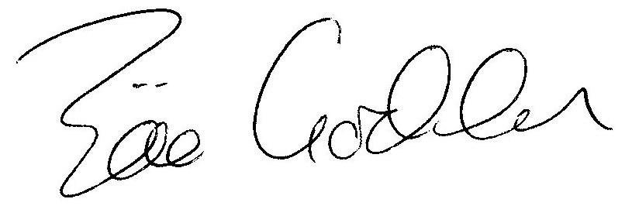

Zöe Godden
Parish Clerk

