CHARLTON HORETHORNE PARISH COUNCIL

A Meeting of the Council on Monday 29 February 2016 at 7.30 pm in the Village Hall to transact the following business:

- To receive any apologies.

- Public Open Session - to consider any matters raised by members of the public. The Chairman will also invite members of the public to contribute during the meeting on appropriate matters.

- Members’ declaration of interests

- To approve the minutes of the meeting held on 11 January 2016

- To consider matters arising from the minutes:
- Community Plan - To hear an update on progress with the Community Plan. (GM)
- To hear an update on the ownership status of the Waterhouses. (GM)
- To hear an update on the Road Safety project and the matter of HGVs driving through the village and to decide any further action to be taken. (TD)
- To hear an update of the provision of superfast broadband to the parish. (MH)
- Any other matters arising.

- Policy Matters
- To consider draft Standing Orders, Financial Regulations and Code of Conduct.

- Council Matters
- To discuss and agree dates for future meetings based on the following:
23/05/2016 – Annual Parish Council Meeting
11/07/2016
26/09/2016
31/10/2016
12/12/2016
23/01/2017
27/02/2017
19/03/2017 – Annual Parish Meeting
- To agree arrangements for the Annual Parish Meeting, to be held on Sunday 20 March.
- Transparency Code: To review a draft layout of the new Parish Council website and to agree any amendments and additions; to hear feedback from the Clerk’s attendance at Transparency Code training.
- To consider applying for the Local Councils Awards Scheme.

- Financial Matters
- To approve the cash book and bank reconciliation for the period to 31 January 2016.
- To approve the following accounts for payment and two signatories for cheques:-
Charlton Horethorne Village Hall | Jan and Feb 2016 Hall Hire | £32.00
Toner 24 | 2 x black ink cartridges for Clerk's printer | £16.27
LGRC (Associates) Ltd | Transparency Code training for Clerk | £72.00
Zöe Godden | Salary & expenses Jan and Feb 2016 | £245.70
HMRC | Income tax re Sept 2015 to Feb 2016 | £184.60
Henstridge Parish Council | 15% of Clerk’s SLCC membership | £22.35

- To note that the Clerk has submitted the precept request to SSDC for the sum of £6013 as agreed at the previous meeting.
- To note that the Clerk has been asked to allow the local Walking Group to use the Parish Council’s bank account to process a grant cheque from the SCC Health and Wellbeing fund and to agree any further action to be taken.
- To note the return of the cheque for £65 sent to the Society for Local Council Clerks for the Clerk’s annual membership, as the total amount due had been calculated incorrectly.
- To agree that two signatories will sign a letter to NatWest bank to request cancellation of two cheques: one grant to the British Red Cross from June 2014 and one to SLCC for the Clerk’s 2016 membership fee – see 7e above.
- Any other financial matters.

- Correspondence
- NALC – Letter asking councils to consider organising an event for the Queen’s 90th birthday celebrations; to decide any action to be taken.
- SSDC – Invitation to attend a South Somerset Together event regarding Welfare Reform on 17th March; to decide if a member should attend.
- SSDC – Invitation to comment on the Draft Community Infrastructure Levy Charging Schedule; to decide a member(s) to comment.

- Planning
- To consider the following planning application and make a recommendation to SSDC.
16/00040/S73A | Application to vary condition 2 of planning approval 12/00117/FUL to reflect alterations during construction and substitute drawing number 182/11 with drawing number 182/11B | Mr & Mrs D Martinez, Former Barn and Stables, Clare Cottage, Stowell Road, Stowell. DT9 4PD

- To consider commenting on a planning appeal in respect of the following application:
15/02187/FUL | Proposed development of Solar Photovoltaic Modules including an access track leading from Station Road; Temporary Construction Compound; Double Inverter Platforms; Transfer Station; Collecting Station; Security Fencing; CCTV cameras and poles; landscaping; and associated works and infrastructure including underground cable along Old Bowden Way and related equipment to allow connection to the electricity distribution network | Land OS 2269  Old Bowden Way  Milborne Port  Sherborne  Dorset | Refused by SSDC

- Items of Report / Future Business
To hear feedback from the Clerk on the Parish Environmental Warden Scheme and to agree any further action to be taken.

- Date of Next Meeting: 11 April 2016.

- Public Open Session: to receive feedback on matters discussed and suggestions for future topics for parish council meetings

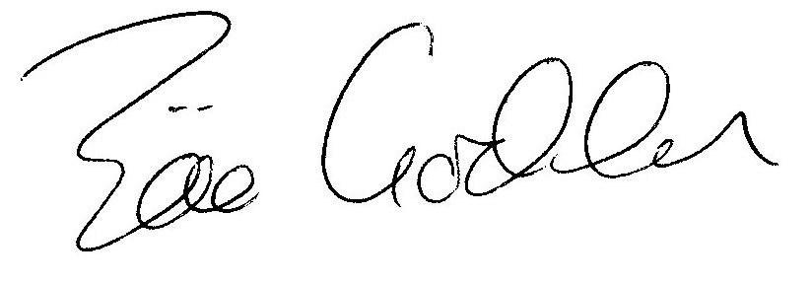

Zöe Godden
Parish Clerk

