CHARLTON HORETHORNE PARISH COUNCIL

A Meeting of the Council on Monday 11 April 2016 at 7.30 pm in the Village Hall to transact the following business:

- To receive any apologies.

- Public Open Session - to consider any matters raised by members of the public. The Chairman will also invite members of the public to contribute during the meeting on appropriate matters.

- Members’ declaration of interests

- To approve the minutes of the meeting held on 29 February 2016

- To consider matters arising from the minutes:
- i. To hear feedback from the Community Plan consultation, which was part of the Annual Parish Meeting.
ii. To approve the Community Plan Policies version PC 1.1.
- To hear an update on the ownership status of the Waterhouses. (GM)
- To hear a report on the response sent to SSDC regarding the Community Infrastructure Levy. (TG)
- Any other matters arising.

- Policy Matters
- To adopt the Standing Orders, Financial Regulations and Code of Conduct as distributed by the Clerk.
- To adopt six additional policies required by the Standing Orders and the Clerk’s contract of employment. These are: Data Protection document, Disciplinary Procedure, Equal Opportunities Policy, Grievance Procedure, Health and Safety Policy and Sick Absence Policy.

- Planning
- To consider the following planning applications and make a recommendation to SSDC.
i) | 16/00935/OUT | Outline application for the erection of a detached dwelling | Mr & Mrs Kingman, Land OS 2000 Between The Dairy House and Grangers, Stowell Road, Stowell.
ii) | 16/01165/FUL & 16/01166/LBC | Conversion of two storey barn. Erection of a single storey link building and alterations to 1970's extension | Mr R Thornham, The Old Parsonage House, High Street, Charlton Horethorne. DT9 4NL

- To note that a planning application has been submitted as follows and that SSDC does not have to consult the Parish Council on this matter; to agree any further action to be taken:
16/00929/PAMB | Prior approval for the change of use of agricultural stock buildings to two dwellings | Hopkins Developments Ltd, Land Os 9090 Part, Charlton Horethorne, Sherborne, DT9 4PH

- Council Matters
- To discuss the recent Annual Parish Meeting and note any suggestions for the future.
- Transparency Code: To hear an update on progress with the website and to decide if it should be called “charltonhorethorne.org.uk” or “charltonhorethornepc.org.uk”. (Clerk)
- To consider allowing the Clerk to attend the free-of-charge “Clerk’s Briefing” run by SALC; to agree to share the mileage costs with Henstridge Parish Council, amounting to £11.03.
- To confirm Tony Magson as the Parish Environmental Warden.

- Financial Matters
- To approve the cash book and bank reconciliation for the period to 31 March 2016.
- To approve the following accounts for payment and two signatories for cheques:-
Charlton Horethorne Parish Church | Churchyard maintenance grant | £385.00
Charlton Horethorne Village Hall | Maintenance grant | £400.00
Citizens' Advice Bureau (South Somerset) | Grant for drop-in centre | £50.00
Millennium Green Trustees | Maintenance grant | £1200.00
Stowell Parish Church | Maintenance grant | £250.00
Parish Magazine | Grant towards publication costs | £50.00
Tim Daniel | Refund for APM drinks | £72.25
Geoff McHugh | Refund for APM food | £83.16
Henstridge Parish Council | 1/2 fee for Clerk attendance on Planning Training | £75.00
Charlton Horethorne Village Hall | 2 x invoices: Community Plan (£40.00) & PC (£32.00) | £72.00
Zöe Godden - | Salary & expenses March 2016 | £194.56
HMRC | Income tax re Z Godden | £30.80

- To approve the end of year budget vs spend for 2015-2016.
- To consider quotes for the Village Green maintenance contract.
- Any other financial matters.

- Correspondence
- Charlton Horethorne Parochial Church Council – Thank you letter regarding the Parish Council grant.

- Items of Report / Future Business

- Date of Next Meeting: 23 May 2016 – this will be the Annual Parish Council Meeting.

- Public Open Session: to receive feedback on matters discussed and suggestions for future topics for parish council meetings

- Exclusion of Press and Public: To consider exemption of press and public for remainder of meeting under Public Bodies Admissions To Meetings Act 1960, Section 1 (2) on the grounds that discussion of the following business is likely to disclose confidential information.

- Personnel Matters
- To consider confirming the Clerk’s contract of employment following completion of the trial period.
- To agree that Clerk’s annual leave entitlement should be increased from 21 to 25 days following 5 years’ continuous Local Government Service.

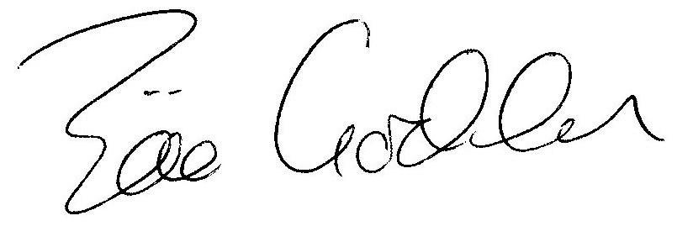

Zöe Godden
Parish Clerk

